RKS Testing System

1. 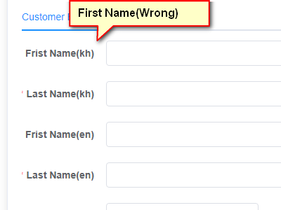មើលពាក្យខុស

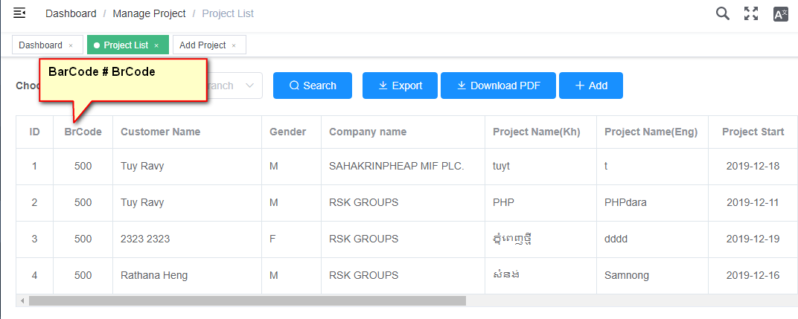

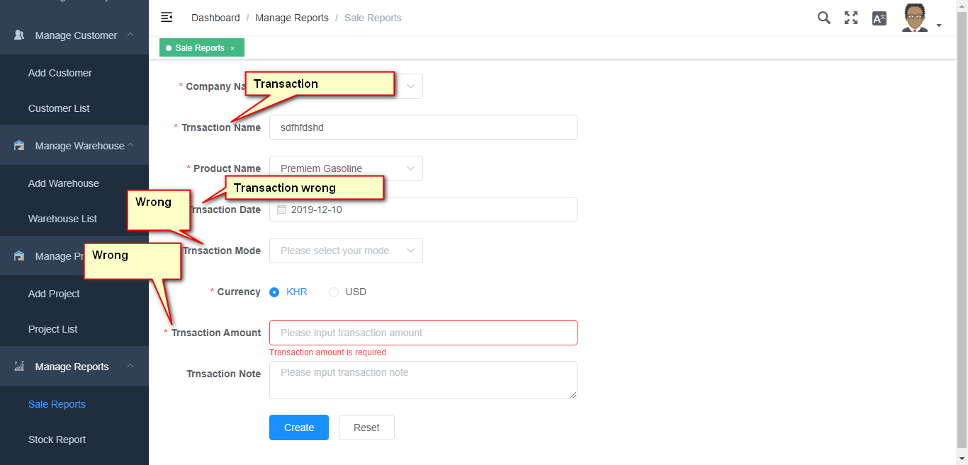

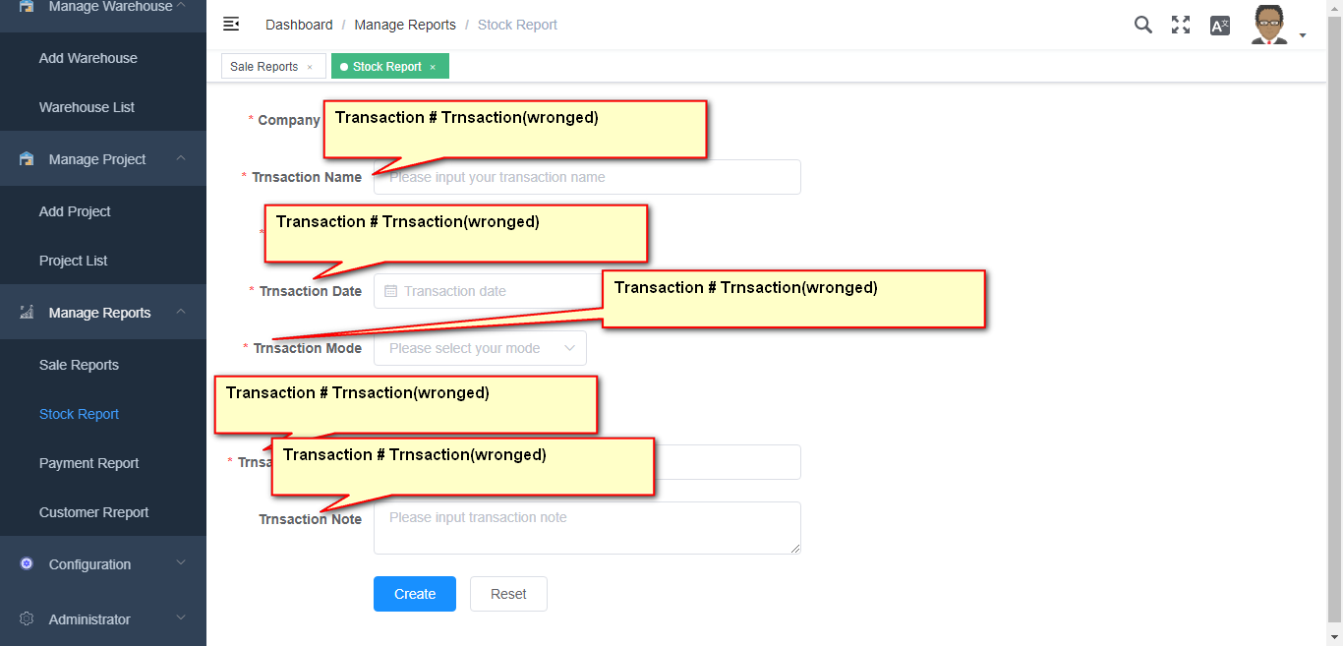

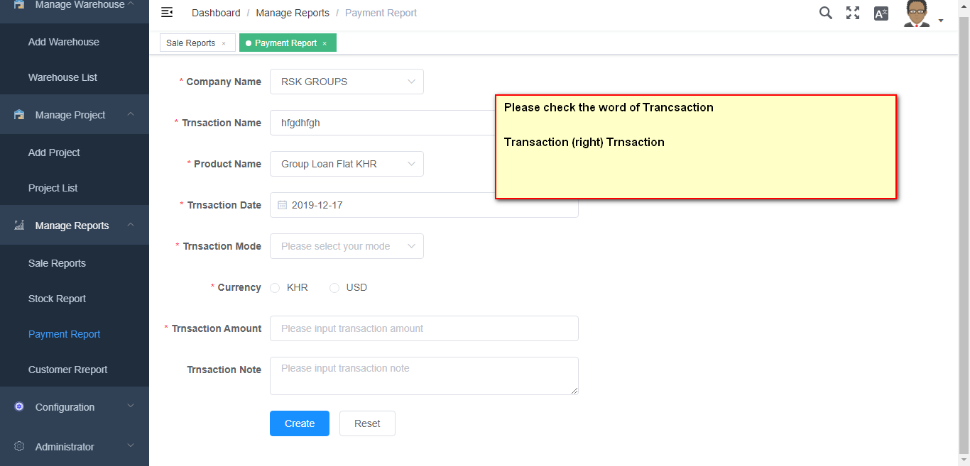

1. Manage Customer
   1. Add Customer
   2. Customer
      1. Edit
      2. Delete
      3. Approved
      4. Export
      5. Download pdf (cannot download to pdf)

* Test process

1. Manage Warehouse
   1. Add Warehous

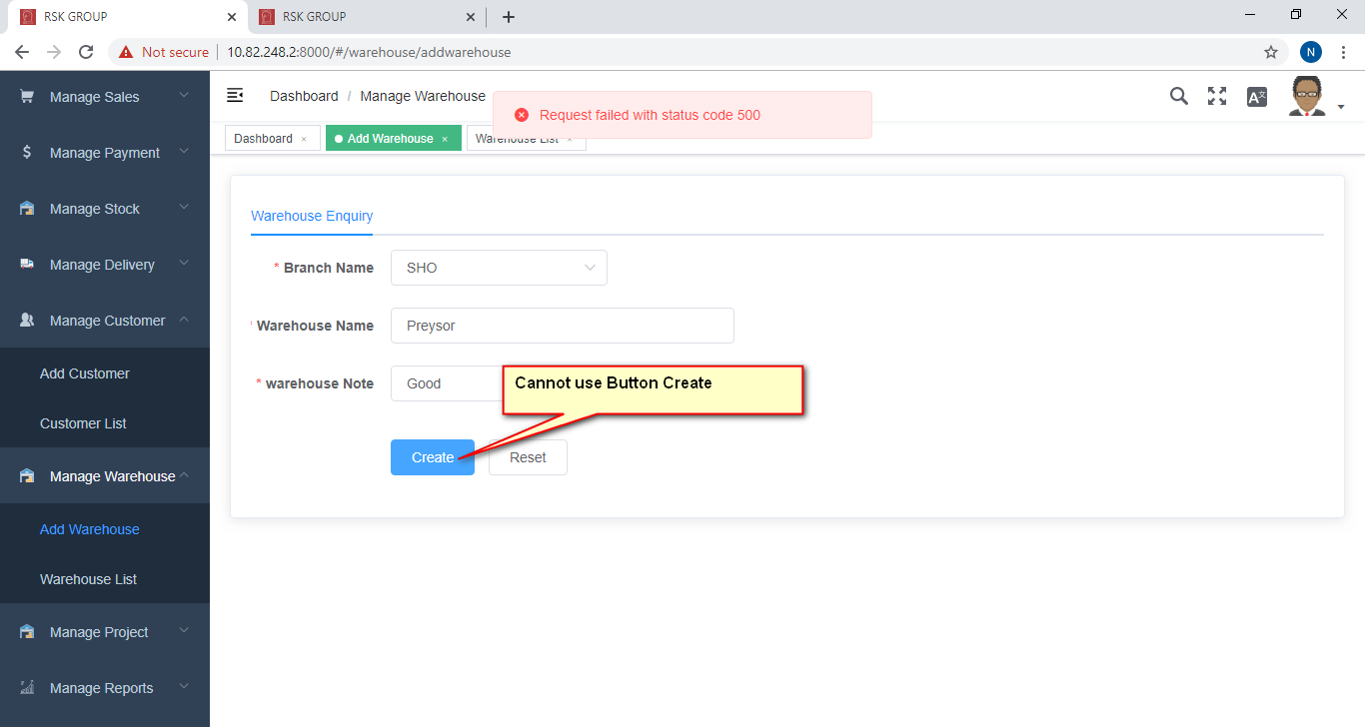

* 1. Warehouse list

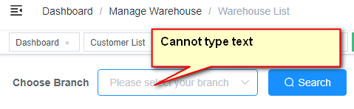

* + 1. Edit
    2. Delete
    3. Approved
    4. Export
    5. Download pdf (cannot download Pdf)
* Test Process

1. Manage Project
   1. Add Project
   2. Project list

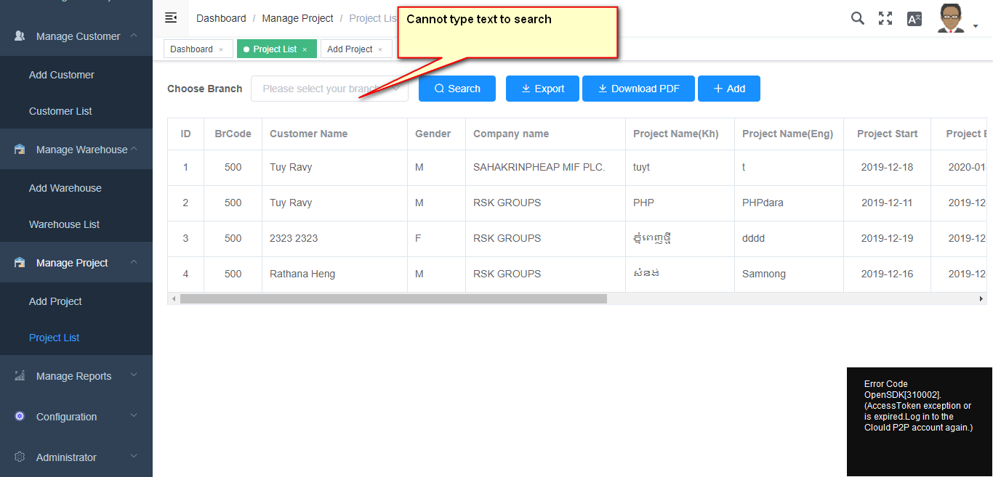

* + 1. Edit
    2. Delete

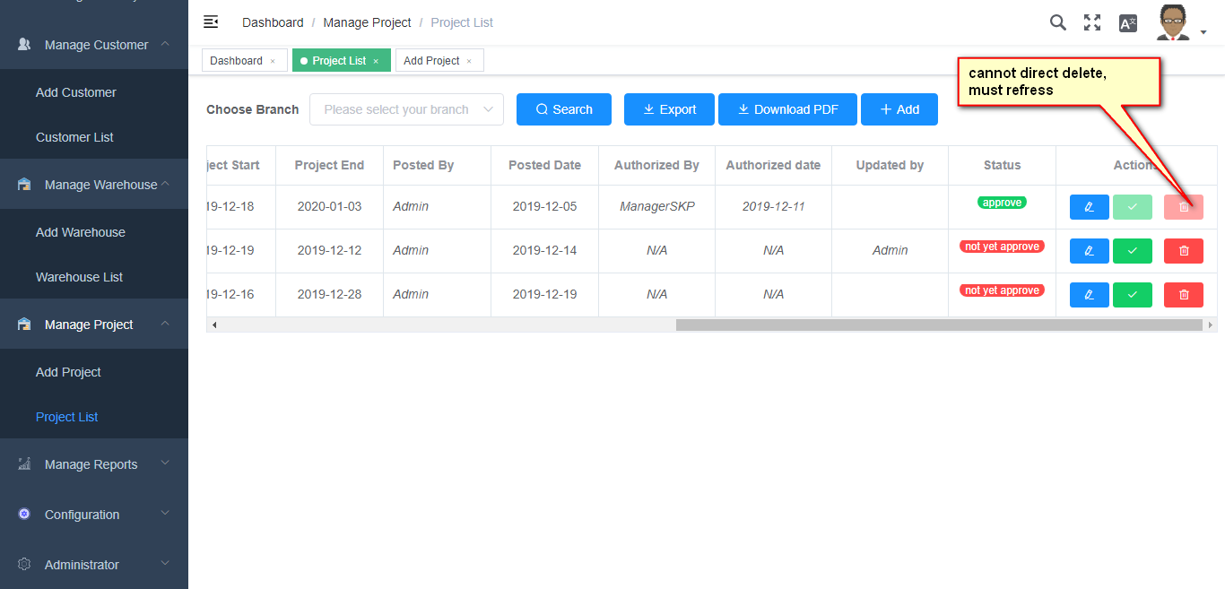

* + 1. Approved
    2. Exports
    3. Download Pdf
* Test Process

1. Manage Reports
   1. List Reports
      1. Sale Reports

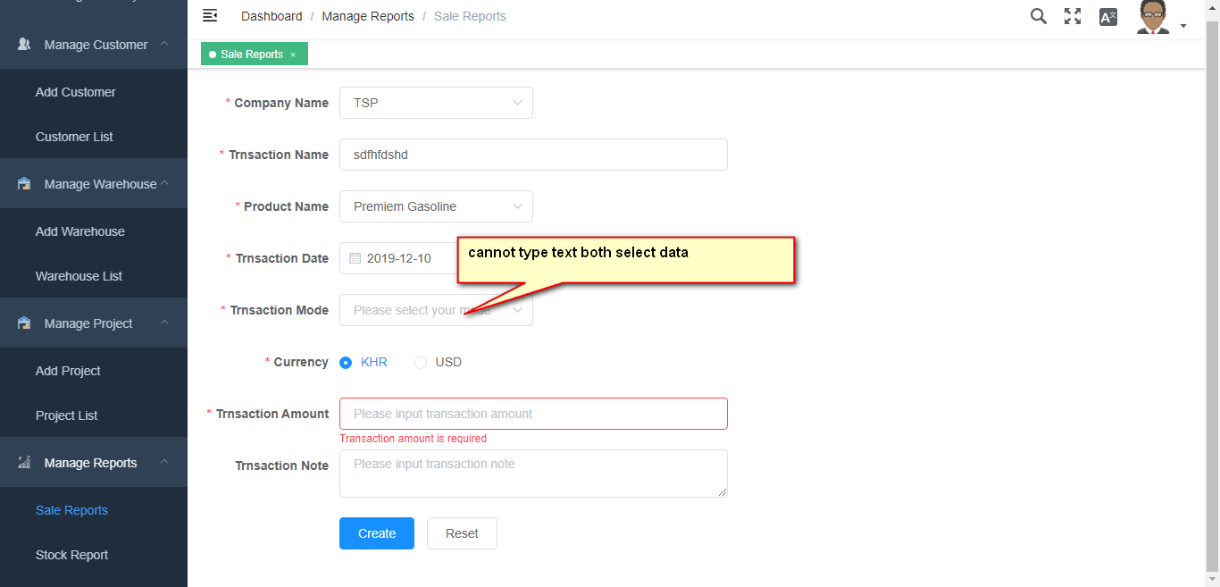

* + 1. Stock Reports

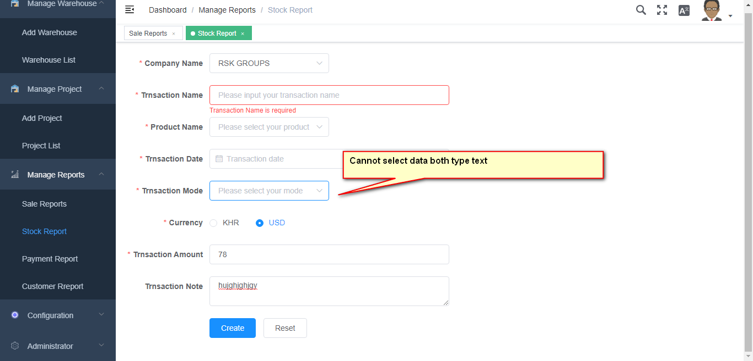

* + 1. Payment Reports

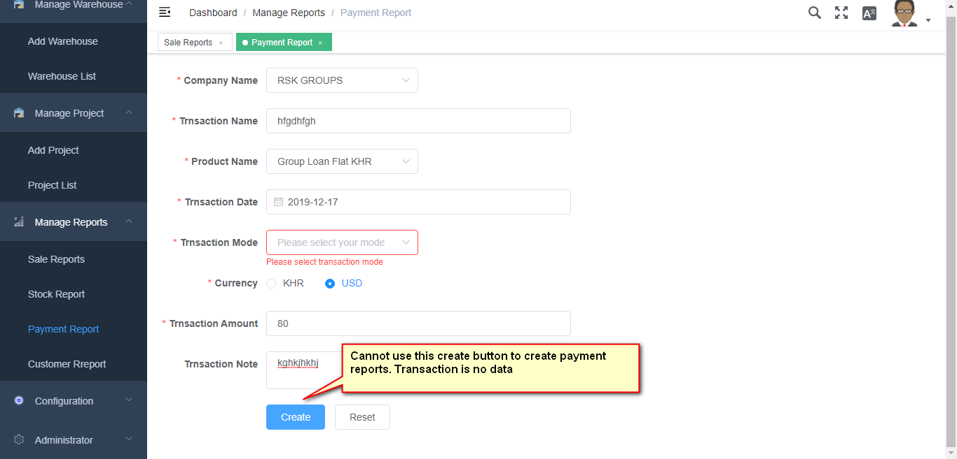

* + 1. Customer Reports

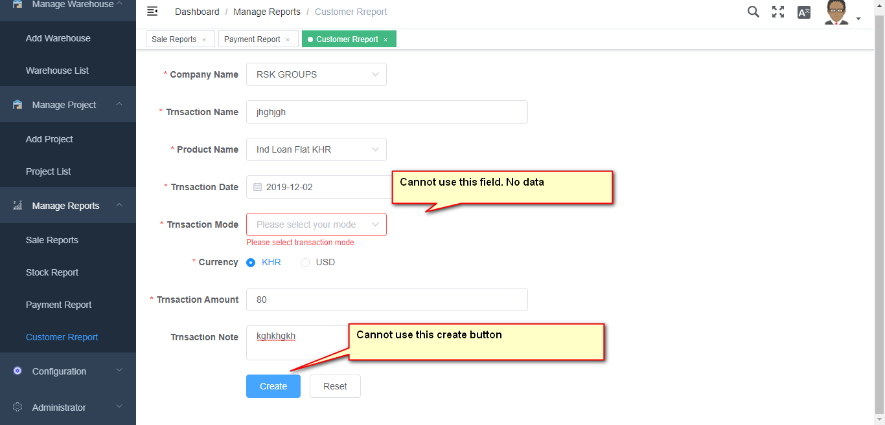

* Verify Report Name

1. Manage Stock
   1. Stock Transaction
   2. Stock List
      1. Edit
      2. Delete
      3. Approved
      4. Exports
      5. Download (Cannot download PdF)
2. Manage Payment
   1. Add Payment

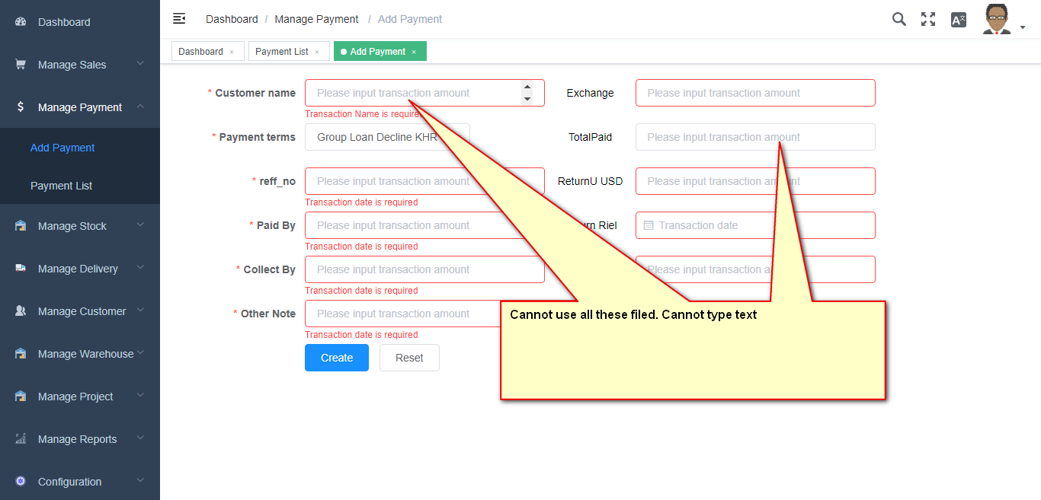

* 1. Payment List
     1. Edit
     2. Delete
     3. Approved
     4. Exports
     5. Download

1. Administrator
   1. User
      1. Create New User

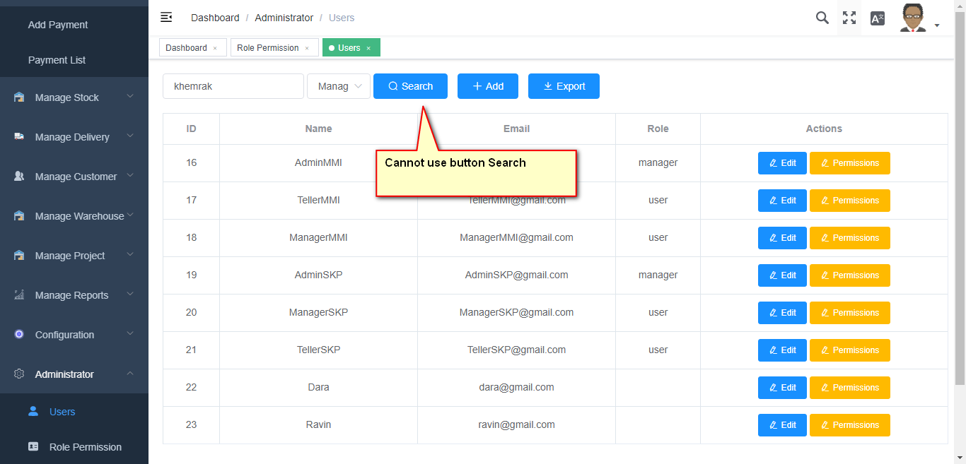

* + 1. Edit
    2. Add Permissions
    3. Exports
  1. Role Permission
     1. Add Role
     2. Check Role